TG-51 Worksheet A: Photon Beams

- Site data
Institution:
Physicist:
Date:
Accel or ⁶⁰Co Mfr.:
Model & serial number:
Nominal photon energy/beam identifier: MV
- Instrumentation
a. Chamber model:

Serial number:
Cavity inner radius (r_{cav}, Table III): cm

Waterproof: yes no

If no, is waterproofing ≤ 1 mm PMMA or thin latex?: yes no
b. Electometer model:

Serial number:
i. P_{elec}, electrom. Corr factor ( Sec. VII.B): C/C or C/rdg.
c. Calibration factor N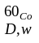 (Sec.V): Gy/C (or Gy/rdg)

Date of report (not to exceed 2 years):
- Measurement Conditions (10 x 10 cm², point of measurement at 10 cm depth (water equivalent)
a. Distance (SSD or SAD): cm SAD or SSD
b. Field size: cm²
on surface (SSD setup)
at detector (SAD setup):

c. Number of monitor units: MU (min for ⁶⁰Co)
- Beam Quality ( Sec. VIII.B – not needed for ⁶⁰Co
If energy <10 MV, use no lead foil.
Measure %dd (10) [% depth-dose at 10 cm depth for curve shifted upstream by 0.6r_{cav}]

Field size 10 x 10 cm² on surface, SSD = 100 cm: yes no
a.%dd(10)_{x} = % dd(10)

If energy ≥ 10 MV

Distance of 1 mm lead foil phantom surface 50 ± 5 cm 30 ± 1 cm
Measure % dd(10) _{Pb} [% depth-dose at 10 cm depth for curve shifted upstream by 0.6 r_{cav}]

Field size 10 x 10 cm² on surface, SSD = 100 cm: yes no
%dd(10)_{Pb}(includes e-contamination):
50 cm: %dd(10)_{x} = [0.8905 + 0.00150%dd(10)_{Pb}]%dd(10)_{Pb} [%dd(10)_{Pb} ≥73%] Eq.(13)
30 cm: %dd(10)_{x} = [0.8116 + 0.00264%dd(10)_{Pb}]%dd(10)_{Pb} [%dd(10)_{Pb} ≥71%] Eq. (14)
If %dd(10)_{Pb} < 71% (30 cm) or 73% (50 cm): %dd(10)_{x} = %dd(10)_{Pb}
b. %dd(10)_{x} (for open beam):

Has lead foil been removed? yes no

Interim alternative for energy > 10MV & with ≥ 45 cm clearance: using no lead foil
Measure %dd(10) [% depth-dose at 10 cm depth for curve shifted upstream by 0.6 r_{cav}]
%dd(10): No lead
%dd(10)_{x} = 1.267 (%dd(10) – 20.0 [for 75% <%dd(10) ≥ 89%
c. %dd(10)_{x} =

TG-51 Worksheet A: Photon Beams (cont’d)

5 Determination of k_{Q} (Sec. IX. B)
Chamber model used to get k_{Q}:
a. %dd(10)_{x} (from 4, above):
b. k_{Q} [Table I or Fig. 4]:

- Temperature/pressure Correction (Sec.VII.C)
- Temperature: ºC
- Pressure: kPa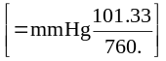
- P_{TP}: 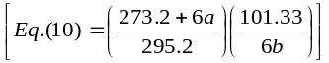
- Polarity correction (Sec. VII. A.)
M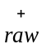: C or rdg
M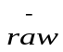: C or rdg
a. M_{raw} ( for polarity of calibration): C or rdg
b. P_{pol}: 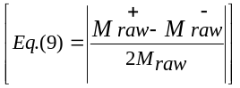
- P_{ion} measurements (Sec.VII. D. 2)
Operating voltage = V_{H}: V
Lower voltage V_{L:} V
M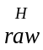: C or rdg
M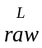: C or rdg
⁶⁰Co treated as general recombination
a. P_{ion}(V_{H}) (Eq.(11)); 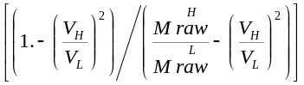

Pulsed/swept beams
b. P_{ion} (V_{H}) (Eq.(12)) 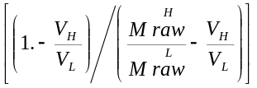
If P_{ion} > 1.05, another ion chamber should be used.
- Corrected ion. ch. rdg. M (Sec.VII) at 10 cm depth, water equivalent

M = P_{ion}P_{TP}P_{elec}P_{Pol}M_{raw} = [8(a·or·b)·6c·2bi·7b·7a]

Fully corrected M (Eq.(8)):
10. Dose to water at 10 cm depth: 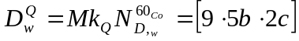 Eq. (3)
a. Dose to water at 10 cm depth =
Gy/MU
b.Dose/ MU(or min ⁶⁰ Co) at 10 cm depth [10a/3c]

- Dose to water/MU(or min,⁶⁰Co) at dmax (if relevant locally)
a. Clinical %dd(10) for SSD setup / 100.:
or clinical TMR(10, 10 x 10) for SAD setup:
b. Dose / MU(or min, ⁶⁰Co) at dmax: Gy/MU [10b/(11a)]
cGy (water)/MU

